Hackerrank question
Grading Students | HackerRank
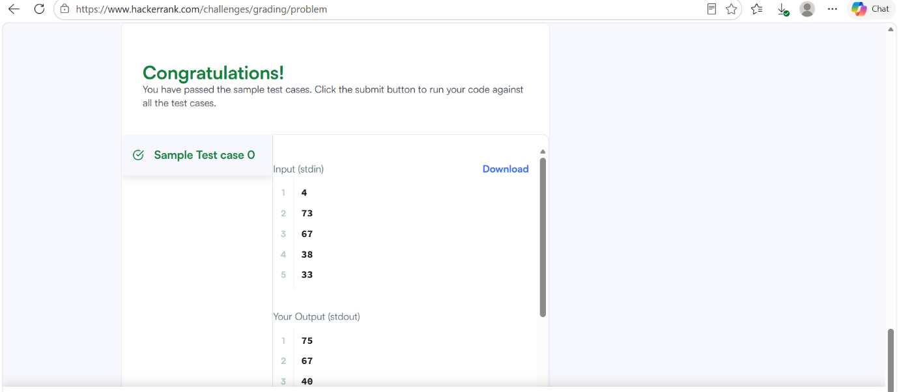

Code
#include <assert.h>
#include <ctype.h>
#include <limits.h>
#include <math.h>
#include <stdbool.h>
#include <stddef.h>
#include <stdint.h>
#include <stdio.h>
#include <stdlib.h>
#include <string.h>
char* readline();
char* ltrim(char*);
char* rtrim(char*);
int parse_int(char*);
int* gradingStudents(int grades_count, int* grades, int* result_count) {
*result_count = grades_count;
int* result = malloc(grades_count * sizeof(int));
for (int i = 0; i < grades_count; i++) {
if (grades[i] < 38) {
result[i] = grades[i];
} else {
int remainder = grades[i] % 5;
if (remainder >= 3) {
result[i] = grades[i] + (5 - remainder);
} else {
result[i] = grades[i];
}
}
}
return result;
}
int main()
{
FILE* fptr = fopen(getenv("OUTPUT_PATH"), "w");
int grades_count = parse_int(ltrim(rtrim(readline())));
int* grades = malloc(grades_count * sizeof(int));
for (int i = 0; i < grades_count; i++) {
int grades_item = parse_int(ltrim(rtrim(readline())));
*(grades + i) = grades_item;
}
int result_count;
int* result = gradingStudents(grades_count, grades, &result_count);
for (int i = 0; i < result_count; i++) {
fprintf(fptr, "%d", *(result + i));
if (i != result_count - 1) {
fprintf(fptr, "\n");
}
}
fprintf(fptr, "\n");
fclose(fptr);
return 0;
}
char* readline() {
size_t alloc_length = 1024;
size_t data_length = 0;
char* data = malloc(alloc_length);
while (true) {
char* cursor = data + data_length;
char* line = fgets(cursor, alloc_length - data_length, stdin);
if (!line) {
break;
}
data_length += strlen(cursor);
if (data_length < alloc_length - 1 || data[data_length - 1] == '\n') {
break;
}
alloc_length <<= 1;
data = realloc(data, alloc_length);
if (!data) {
data = '\0';
break;
}
}
if (data[data_length - 1] == '\n') {
data[data_length - 1] = '\0';
data = realloc(data, data_length);
if (!data) {
data = '\0';
}
} else {
data = realloc(data, data_length + 1);
if (!data) {
data = '\0';
} else {
data[data_length] = '\0';
}
}
return data;
}
char* ltrim(char* str) {
if (!str) {
return '\0';
}
if (!*str) {
return str;
}
while (*str != '\0' && isspace(*str)) {
str++;
}
return str;
}
char* rtrim(char* str) {
if (!str) {
return '\0';
}
if (!*str) {
return str;
}
char* end = str + strlen(str) - 1;
while (end >= str && isspace(*end)) {
end--;
}
*(end + 1) = '\0';
return str;
}
int parse_int(char* str) {
char* endptr;
int value = strtol(str, &endptr, 10);
if (endptr == str || *endptr != '\0') {
exit(EXIT_FAILURE);
}
return value;
}

